
TOURS BY AJALA
JAMAICA TOUR ITINERARY

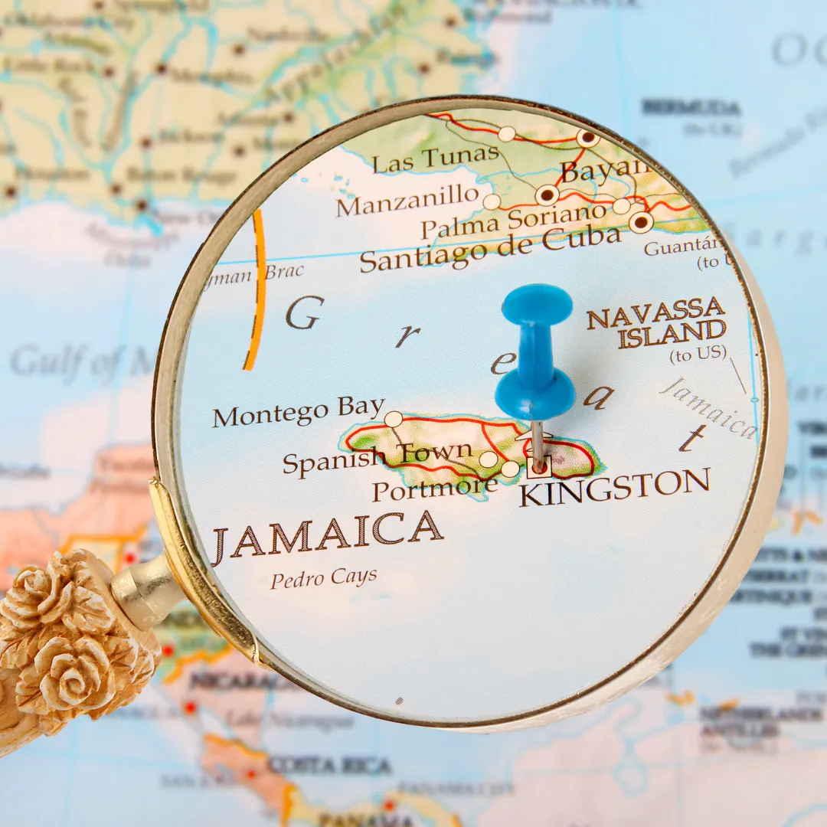

Day 1: Kingston

Arrival at Kingston International Airport. Clear customs and meet your driver and escort holding a sign: “The Ajala Group”. You may change money at the currency exchange desk before meeting your driver.

After leaving the airport, your first stop will be at historical Port Royal, a village at the mouth of Kingston Harbor. Founded in 1494 by the Spanish, it was once the largest city in the Caribbean. It was destroyed by an earthquake in 1692.

Stop for a late lunch and continue on a brief tour of Kingston on your way to your hotel.

Check-in - The Kingston Hotel - Welcome Cocktail. Evening at your leisure.

​Day 2 - ART & MUSIC

Meet at 10:00am in the Hotel Lobby for a full-day of touring:

You'll start your cultural experience by first visiting the Bob Marley museum situated on the site of the legendary musician's home. The house, featuring 19th-century architecture, was Marley's home until his death in 1981. It was converted into a museum six years later by his wife, Mrs. Rita Marley. The main museum displays Marley's personal treasures. Housed in two rooms of the museum you will tour the Rita Marley exhibition which features photographs, articles of clothing and other items showcasing the diverse paths of Rita Marley's multifaceted life.

Your next stop will be at the Jamaica Music Institute where you will be immersed into the music history and culture of Jamaica through a participative and interactive experience.

Lunch (not included)

Take a short walk/drive to Trench Town to see where the Reggae Legends lived and the Art Murals in Culture Yard.

Return to Hotel – Evening at your leisure.

Day 3: WELLNESS

Check-out of Hotel.

10:00 am: Hotel Pick-up for a 2.5-hour drive to “Zimabali” for a personalized organic farm-to-table experience. You'll tour and learn about the wide array of plant life ranging from fruit trees to vegetables located on the property. Whatever is going to be on the menu will be harvested from the farm … a true rustic gourmet experience!

Relax on a 1-hour drive to Negril

Check in at your beachfront ‘Boardwalk Village’ Hotel

Day 4 - YS Falls

10:00 am: Meet in the Lobby for a 1.5-hour drive to YS Falls, one of Jamaica's finest natural waterfalls. There are seven waterfalls, most cascading into natural pools, surrounded by lush gardens and magnificent trees. Some areas are rocky, and river shoes are recommended. The water is cold but very refreshing.

Lunch (not included)

Return to Hotel – Evening at your leisure

Day 5 -

9:00 am Yoga on the beach deck.

11:30 am – Hotel Pick-up:

Your day continues with a glass-bottom boat ride exploring the waters surrounding Negril. You'll visit the famous Booby Cay, a very small offshore island in Negril. There are plenty of coral reefs on this island, providing a breeding place for a huge population of vibrant marine life. The presence of coral reefs makes the island an excellent place to experience snorkeling and scuba diving. Enjoy lunch on the beach along with a variety of organic treats.

Return to Hotel – Late Afternoon / Evening at your leisure

Optional Activities: Ricks Café (Dinner and Music)

Day 6 -

Day at Your leisure - Shopping at Craft Market, Optional Activities are Available (Please Inquire).

Day 7 – DEPARTURE
Check out of Hotel. Transfer to Montego Bay Airport for your Departure Flight.
.



