
TOURS BY AJALA
PANAMA TOUR ITINERARY

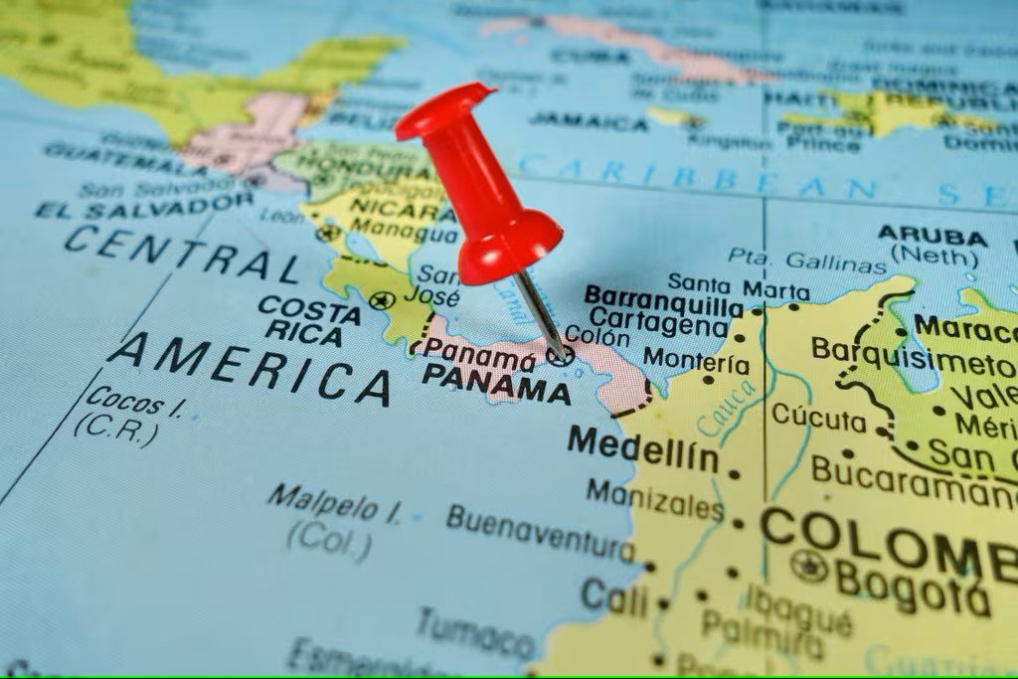

Day 1:

Private Airport/Hotel Transfer

Overnight at Hilton Garden Inn hotel

Day 2: (B)

Breakfast in the hotel

8:30 am Private tour Panama Canal Tour & City Tour

Overnight at Hilton Garden Inn hotel

Day 3: (B - L)

Breakfast in the hotel

8:30 am Private tour to Embera Community, Typical lunch included

Overnight at Hilton Garden Inn hotel

Day 4: (B)

Breakfast in the hotel

Day at Your Leisure

(See Optional Tours)

Overnight at Hilton Garden Inn Hotel

Day 5: (B)

Breakfast in the hotel

8:30 am. Private tour to Colon City

Overnight at Hilton Garden Inn Hotel

Day 6: (B)

Breakfast in the hotel

Transfer Hotel/Airport



