
TOURS BY AJALA
MOROCCO TOUR ITINERARY
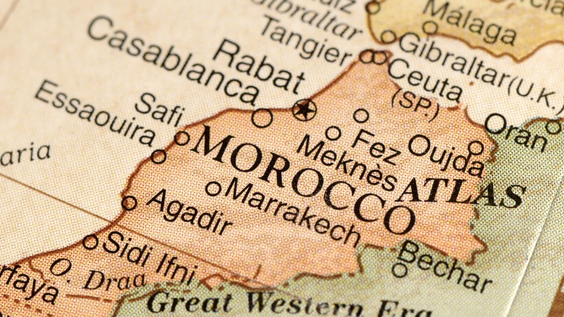

Day 1: Hassan II Mosque Tour

Visit the stunning Hassan II Mosque, the largest in Morocco and the third largest mosque in the world, which non-Muslims are allowed to enter. Able to accommodate up to 105,000 in prayer, this marvel of modern Moroccan architecture is the work of hundreds of expert craftsmen from around the country, many of them donating their work.

This guided 1-hour tour will take you through the prayer hall and the ablution area. Please be prepared to remove your shoes in the prayer hall.

​An oasis of elegance, Hyatt Regency Casablanca is located a few steps away from the medina and the art deco buildings in the historical center of Casablanca. A mythical address to discover this legendary, vibrant, and cosmopolitan city. Our hotel is known for its luxurious atmosphere and its innate sense of hospitality, blending heritage and modernity.

​Day 2 - Casablanca to FES

Depart from Casablanca to travel back down the mountains and south to Fes, the oldest city in Morocco.

Tour Fes with a private guide.

Visit the ancient Roman ruins of Volubilis. These ruins date back to 3 BCE, and were once the capital of the ancient kingdom of Mauretania. The ruins are still undergoing excavation, and several of the mosaic floors still shine with vivid colors when wet.

Benefit from a traditional hammam session, Massage or receive cosmetic treatments. Then enjoy the solarium and have tea or a breakfast on the terrace from which you can admire the two Borjs, part of the medina and the nearby Zalagh mountain. In the evenings you can admire the wonderful sunsets and dine on the terrace. In warmer days, the heated patio, the lounge where a bonfire fire burns in its high fireplace, will welcome you to read, play, listen to music, watch a movie or savor a delicious traditional meal.

﻿The team of DAR VICTORIA will be happy to propose you what is concocted lovingly in its kitchen: Moroccan breads, viennoiseries, typical pastries, sorbets and jams. But also, if you wish, a meal in the respect of culture and dietetics.

Day 3 - Tour of Fes

Tour Fes with a private guide.

The city of Fes is a destination that will take your breath away with its stunning architecture and beautiful views. You can begin your tour at the Royal Palace. The centuries-old palace features seven intricately decorated golden doors that are laden with Moroccan symbolism. Stroll through Mellah - the historically Jewish quarters located next to the palace, built to protect its inhabitants and believed to date from the mid-15th century.

From the top of Borj Sud, you can see all of the city of Fes laid out before you. The vantage point gives you the opportunity to view landmarks that are often hidden by the city's skyline-obstructing buildings.

The pottery of Fes is a unique and ancient art form that has been perfected over the centuries and handed down through generations. Visit a pottery co-op to experience the operations. You will also get a close-up look at beautiful pieces from this vibrant cultural center!

Another cultural landmark of Fes is the Al-Quaraouiyine University. The university is the oldest degree-granting institution still in operation, having been founded by a woman 859 years ago. Although you are not allowed to enter this Quoranic school, you can catch a glimpse of the stunning courtyard.

​Head into the ancient medina and step back into time in this living museum of sorts. The Fes Medina has been continuously inhabited since 250 A.D. and boasts a rich cultural history. The obscure gem is full of life and activity with its present-day inhabitants living in the midst of a bustling marketplace.

While in the medina, be on the lookout for donkeys! These sturdy creatures carry loads through the winding alleyways, where motorized vehicles are not permitted. The medina's handicraft workshops offer a unique insight into the country's ancient culture and history. Visitors can witness how traditional techniques are still being used today.

Examples of these techniques can be observed through silk weavers who produce beautifully colored fabrics from threads sourced exclusively within Morocco; or those used for animal hide tanning, a process which has been carried out for nearly a millennia.

Lunch in the medina is included in your tour of Fes. This unassuming restaurant has been serving up delicious fare since 1680 and offers up a surprise as you walk through its doors. This gem features an enticing tajine menu with an array of options that will not only satisfy but also excite any appetite!

Day 4 - Fes to Merzouga

Depart Fes to journey south to the Sahara Desert - 8 hours

Make a coffee stop in Ifrane, an adorable ski resort town that's also known as the Swiss village due to its alpine-style architecture.

Visit the monkeys in their natural habitat outside of Azrou, where they are happy to be fed but surprisingly well-mannered.

Take in the scenery as you cross the Atlas Mountains.

View the lush green date and almond trees filling the gorge in Errachidia.

Arrive in Merzouga in the evening

Kasbah Mohayut welcomes you in a tranquil environment in the foothills of Merzouga's towering dunes. It is an excellent option for combining relaxation, authenticity, and adventure! The Kasbah has big rooms and suites that are arranged around the swimming pool or the terrace. Each room mixes traditional Moroccan elements with modern conveniences such as air conditioning.

Day 5 - Exploring the Sahara with the Merzouga Oasis

Spend the day exploring the region. Far from the most populated cities, the Sahara region is unique, in some ways feeling like a step back in time.

Head to the local oasis, learning about the ancient irrigation system still in use today and wandering through the fertile plots of land allotted to the local families to grow their own vegetables.

Visit a local artist studio, where a Berber artist makes incredible sculptures and paintings based on Berber writing, while his wife creates beautiful portraits of Berber men and women.

Stop for lunch in a local home, where you will enjoy medfouna, a local specialty, that was baked in a traditional oven.

Sahara Desert Camel Trek

Meet your camels for your trek into your desert camp. You will journey through the dunes, and your camel guide will be able to get some great pictures for you as well!

Arrive at your camp and enjoy a welcome glass of Moroccan mint tea.

The word MADU has many meanings and expresses many feelings, but it mainly means "respect". This term embodies the philosophy of this family business created by the four Anaam brothers, where they are committed to respect for what is authentic, native customs, traditions, tranquility, in short, for a set of values and sensations that they want to transmit to their clients, making their stay in their establishments a unique and enriching experience. MADU is peace, comfort, personal and family attention, humanity.

Nestled in the heart of the dunes, an hour and a camel ride away, the place escapes all definition.

Magical, cosy, exclusive, unique and incomparable in every way. We are in an authentic oasis in the middle of the desert. We welcome you with tea and traditional homemade pastries and the best of smiles from all our staff.

Day 6 - Rissani Market

Immerse yourself in the dynamic scene of Rissani Market, a bustling gathering point where locals and traders converge for a rich exchange of goods and culture. As one of the region's largest markets, it's a fascinating showcase of daily life in Morocco. Wander through the maze of stalls, where blacksmiths skillfully craft metalware, offering a glimpse into traditional artisan trades.

Pause to explore the section dedicated to dates, a local specialty, where vendors proudly display the region's finest varieties. Additionally, don't miss the lively animal market, where locals engage in the age-old tradition of buying and selling livestock, adding a unique and authentic dimension to the market experience.

Engage with the warm and welcoming locals, known for their hospitality, as you navigate through the market's narrow alleys. Experience the energy of bartering, witness the vibrant transactions, and discover the interwoven threads of daily life in Rissani. The market is not just a place of commerce; it's a vibrant reflection of Moroccan traditions and community life.

Meet up with your driver once more, and begin your journey west.
Make a stop in Tinerhir to see the stunning Todra Gorge, carved from the red rocks of the landscape by a river.
Stop as you pass through Kalaat M'Gouna, which is famous for its production of rose products. The area is known as the Rose Valley because it is where thousands of roses are grown each year to be distilled into rose water and rose oil, then used to make all manner of cosmetics.
In the afternoon, arrive in Ouarzazate, known as "Moroccan Hollywood" thanks to the Atlas Film Studio and other local spots used in filming.
Tin Joseph Guesthouse welcomes you in a setting that combines the cosy location of the place and the beauty of the Moroccan artistic decorations and arts. Since its construction, Tin Joseph has been thriving so as to make your stay comfortable. The architecture of Tin Joseph makes a unique touching decoration that is signifying the charm and contemporary Berber style, relying on hand-made Taddelakt, tailor- made mosaic and furniture so as to offer you a genuine experience during your stay.

Available as a Double or Twin Room (2 single beds).

111_Cohabitation can be connected to 112_Equality.

Day 7 - AIT BENHADDOU, MARRAKECH

Explore Ait Ben-Haddou, a UNESCO World Heritage Site that stands as a testament to Morocco's rich history. Positioned along the historic trade caravan route connecting the Sahara Desert and Marrakech, this ancient Ksar boasts intricate mud-brick architecture that has weathered centuries. Beyond its historical significance, Ait Ben-Haddou has become a popular filming location for notable movies, including The Jewel of the Nile, The Mummy, Gladiator, and Kingdom of Heaven. Wander through the narrow alleys and towering kasbahs, and you'll find yourself stepping into the scenes of these cinematic masterpieces, making your visit a unique blend of history and Hollywood allure.
Ouarzazate to Marrakech - 3.5 hours
Travel over the Atlas Mountains via the winding Tichka Pass to reach Marrakech.
Along the way, you will have the option to stop at an argan oil shop where women from the co-ops in Taroudant will demonstrate how the famed oil is extracted by hand.

In the evening, meet up with a private guide to taste your way through the Marrakech medina with a food tour. Begin with baghrir and sfeng (Moroccan donuts), which can either be sweet, drizzled with honey, or savory, stuffed with vegetables and spices. Continue into the souks, learning about spices and Moroccan tea. Taste a variety of briwat filled with cheese, beef, or vegetables, sample many types of olives, and learn about the many types of Moroccan cookies, from the almond paste stuffed gazelle horns to the fried and honey-drenched chebekia.

End in Jemaa el Fna, where you will find tanjia, a Marrakech specialty, snails cooked in a savory broth, fresh squeezed orange juice, and a unique sweet called zmita.
This Riad is named BAHIA SALAM. It is dedicated to BAHIA (beauty) and SALAM (peace). It is in this idea and this spirit that it was designed and thought out by its owners.
This beauty that we find in the harmony between Arab-Berber architecture, contemporary art and modern comfort.
Not far from the bustling Jemâa El Fna square and the Bahia and Badia Palaces, it is part of this unique and authentic heritage of the medina of MARRAKECH and although in the center, it is easy to access.
Day 8 - Tour of Marrakech

Tour Marrakech with a private guide. This former imperial city boasts a wealth of cultural and historical sites.

Begin with Dar Bacha, which houses the Museum of Confluences, offering a mixture of Berber, Arab, and Jewish artifacts from throughout Morocco’s history. While you are there, be sure to enjoy coffee in their coffee room, offering over 200 varieties of coffee from the world over, housed in a historic palace in Marrakech.

Visit the Koutoubia minaret, the tallest structure in Marrakech. The minaret can be seen from miles outside of the city. Within the city walls, no building is allowed to surpass the height of the Koutoubia, which stands at 253 feet (77 meters). The Koutoubia is part of the largest mosque in Marrakech, and is believed to have been completed in 1199 A.D.

A short distance from the mosque, you can explore Jemaa el Fna, the primary square in the medina and a UNESCO World Heritage site. Though the square is now filled with street performers, snake charmers, merchants and juice stalls, it was originally created in 1050 A.D. to stage public executions. This is perhaps why Jemaa el Fna is translated as "assembly of death".

Head into the souks surrounding Jemaa el Fna to several workshops, including shoemakers and bakers. Stop at one of the iconic spice markets, learning of the medicinal uses of many of the common spices and herbs that are still used across Morocco to treat common illnesses.

Embark on a cultural journey through Marrakech's artistic treasures with a visit to the Majorelle Garden, Yves Saint Laurent Museum, and Berber Museum. Begin amidst the enchanting botanical oasis of the Majorelle Garden, where vibrant flora and cobalt blue architecture create a serene escape.

Continue your exploration at the Berber Museum, housed within the enchanting grounds of the Majorelle Garden, where exhibits showcase the rich heritage and traditions of Morocco's indigenous Berber people.

Finally, delve into the world of fashion and design at the Yves Saint Laurent Museum, celebrating the iconic designer's legacy amidst a stunning collection of haute couture and original creations.

From lush gardens to haute couture and cultural treasures, this immersive experience promises a captivating glimpse into the art, history, and beauty of Marrakech.

Day 9 - Free Time in Marrakech
Savor your leisure time in Marrakech with a myriad of enriching activities.
For a rejuvenating experience, consider indulging in a traditional hammam session, where the ancient ritual involves being covered in black beldi soap, scrubbed with an abrasive kessar mit to renew the skin, and luxuriating in a soothing steam room.

Alternatively, delve into the rich culinary and artisanal traditions of Marrakech by booking a hands-on cooking class or a craft workshop in leather working, wood carving, or pottery making.
If a more relaxed pace appeals to you, simply embrace the charm of Marrakech by wandering through the bustling souks, filled with an array of treasures, and unwind at streetside cafes for some delightful people-watching. Marrakech invites you to create your own unique experience in this captivating city.
Celebrate your final evening in Morocco with a festive farewell dinner set in a beautiful historic building in the heart of the Marrakech medina. As you enjoy traditional Moroccan cuisine, the night comes alive with vibrant music and dynamic performances from local musicians and dancers—a joyful sendoff that captures the spirit and energy of Marrakech. Compliments of the Ajala Group!

Day 10 – DEPARTURE

As your journey has come to an end, your driver will take you to the airport to catch your departure flight.



