
TOURS BY AJALA
DUBAI ESCAPE ITINERARY

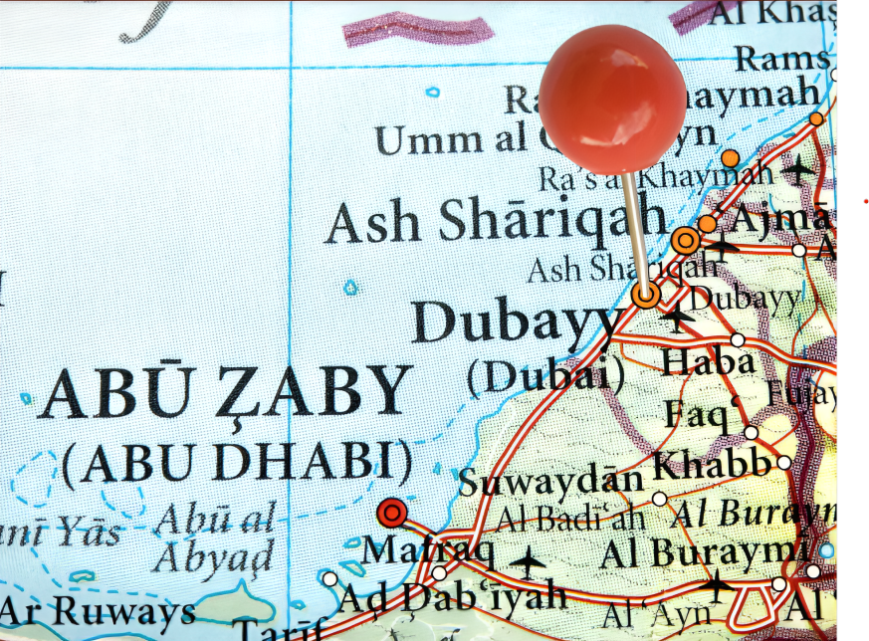

Day 1: USA - Dubai (UAE)

Flight with a good itinerary.

Day 2: Dubai

Arrival at the airport in Dubai. You will be greeted by our local representatives after exiting customs and transferred to your hotel in Dubai. The rest of the day is free for you to discover this beautiful city

Day 3: Dubai

Breakfast at the hotel and departure for a full-day tour of Dubai. You will discover the Burj Al Arab hotel for photos before seeing the awe-inspiring Grand Mosque of Jumeirah. Built in medieval Fatimid style, this stone structure is a tribute to modern Islamic architecture. You will then proceed to Bastakyia, the old town district of Dubai, where you will visit the Dubai Museum located in the ancient fortress of Al Fahidi. Using local water taxis called Abras to cross Dubai Creek, enjoy spectacular views of the city while heading towards the district of Deira. Here, you will be enchanted by the large variety of exotic spices in the famous Spice Souk. Take the chance to get a unique souvenir while visiting the adjacent Gold Souk. You will then stop at the well-known Burj Khalifa located in the Dubai Mall.

Free time for lunch before continuing your tour to the Palm Jumeirah in the afternoon, where you will board the monorail to admire the Palm. Finally, you will visit the Dubai marina and will end at the Mall of the Emirates. Rest of the day at leisure. (Breakfast)

Day 4: Abu Dhabi

Breakfast at the hotel and departure for a full-day tour of Abu Dhabi, the capital city of the United Arab Emirates. Your first stop will be at the Sheikh Zayed Grand Mosque, one of the largest mosques in the world, completely cladded in marble and featuring intricate Islamic decorations and carvings as well as extensive landscaping. Then, you will continue your tour towards Yas island and its Red Ferrari largest covered park.

Stop at the biggest mall of Abu Dhabi for lunch before driving through the giant Saadiyat natural Island project. Visit of the famous Louvre museum before heading back to Dubai. The tour ends near the Mall of the Emirates, you will have the rest of the evening to enjoy a nice dinner in one of the many restaurants available in Dubai. (Breakfast-Lunch)

Day 5: Dubai (UAE) - Desert Safari

Breakfast at your hotel. You will have the morning at leisure. In the

afternoon, you will be driving through the desert of golden sand dunes. After witnessing a memorable, true Arabian sunset with its glory and magic, you will reach the main campsite where you will get the chance to experience a complimentary camel ride. A delicious barbecue dinner will be prepared on open fires to the sound of an orchestra, soon joined by a traditional dancer. Overnight in Dubai. (Breakfast-Dinner)

Day 6: Al Ain - Sharjah - Dubai

Breakfast included. Full day at leisure to enjoy the facilities of your hotel, relax at one of Duba's many white-sand beaches, or continue your exploration of the city by yourself or by opting for an optional excursion ($).

(Breakfast)

Day 7: Dubai

Cruise along the Dubai Marina, under the illuminated skyline of the city on this dinner cruise. Enjoy the views and sights of popular Dubai landmarks like the Cayan Tower, Marina Mall, and a man-made island as you dine on a buffet dinner with background music playing. Round trip transportation from your accommodation is included. Sail around Dubai on a dinner cruise See views of Dubai’s popular landmarks Includes dinner buffet and round-trip transportation. Stress-free package ideal for first-time visitors

Day 8: Departure

After breakfast at your hotel, you will be transferred to the airport for your return flight home. (Breakfast)

-End of services



