

TOURS BY AJALA

CHRISTMAS MARKETS CRUISE ITINERARY

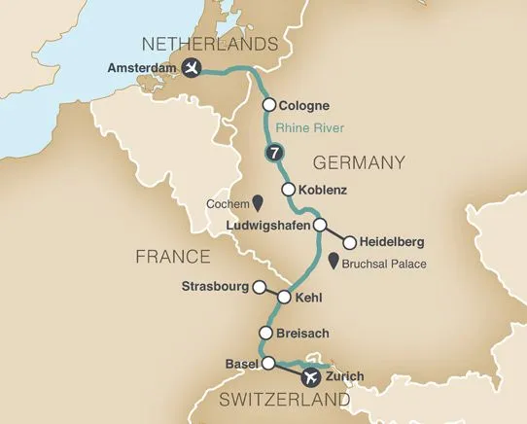

Day 1: Depart the USA

Depart the USA on your overnight flight to Zurich, Switzerland.

Day 2: Zurich - Basel, Switerland

Welcome to Switzerland! Upon arrival, you will be met by a representative of Mayflower Cruises and Tours and transferred to your awaiting motorcoach. Flights should arrive by 12:00pm. Journey to the town of Basel where your captain and crew await to welcome you aboard your luxurious Emerald Cruises Star-Ship. Enjoy time to become acquainted with your new accommodations, and this evening, join your fellow guests for dinner onboard. Your Cruise Director will also conduct a port talk to review the activities and itinerary for the days ahead. Meal: D

[Day 3: Breisach, Germany](tel:(954)%20945-1380)

Begin the day with a guided tour of Breisach, also know as the gateway to Germany’s Black Forest region. This afternoon, enjoy a scenic drive through the Black Forest Highlands on your way to the Hofgut Sternen complex located at the foothill of Ravenna Gorge, a place where history and tradition merge. This was the site where, in 1770, Marie Antoinette stopped with 52 beautifully decorated carriages on the way to her wedding to King Louis XVI. During this holiday season, see the picture-perfect Christmas market situated underneath the 130’ high Ravenna Viaduct where unique handcrafted regional items await your perusal. Meals: B, L, D

[Day 4: Strasbourg, France](tel:(954)%20945-1380)

Upon arrival in Kehl (docking site for Strasbourg), travel by coach across the river to Strasbourg, the capital city of the Alsace Region in France. A local guide leads you on a walking tour through this picturesque town. Stroll along the Grand Île and through the charming Old Quarter, ‘La Petit France’. Admire the historical city center and UNESCO World Heritage Site known for its medieval black and white timber-framed buildings, old tanning houses, baroque sandstone buildings, canals and river locks and its centerpiece, the Gothic cathedral. Enjoy free time to visit the stalls of Strasbourg’s Christkindelsmärik, one of the oldest in Europe, before returning to the ship. Meals: B, L, D

[Day 5: Ludwigshafen - Heidelberg, Germany](tel:(954)%20945-1380)

# From the port of Ludwigshafen, depart by coach for Heidelberg. Your guided tour of Heidelberg’s rich history includes a wine tasting and a visit to the ruins of Heidelberg Castle, overlooking the Neckar River and a red-roofed skyline. A stroll along the cobblestone streets of the Old Town touches on the Church of the Holy Spirit and the oldest university in Germany, further enhancing your visit to this historic city. Don’t miss out on shopping for unique treasures at the Christmas Market in Heidelberg. Meals: B, L, D

# [Day 6: Koblenz](tel:(954)%20945-1380)

# This morning, en route to Koblenz, sail through the spectacular Rhine Gorge, where a landscape of castles and quaint towns awaits. Don’t miss the infamous Lorelei rock and statue and other photo opportunities that abound around every bend. Cruise to the 2000-year-old town of Koblenz, situated at the confluence of the Rhine and Moselle Rivers. During awalking tour of Koblenz, see the German Corner monumentand traverse the cobblestone lanes of the historic city center. A visit to Ehrenbreitstein Fortress, crossing the river via aerial tram, is also included. After the excursion, time to visit more than 100 glittering, festive, cottage-style stands filled with Lebkuchenherzen (traditional gingerbread hearts) and otherspecial treats and handicrafts, all creating a magical European

# Christmas experience. Meals: B, L, D DiscoverMORE: Moselle & Cochem Castle Visit (additional expense)

# [Day 7: Cologne](tel:(954)%20945-1380)

# Seven markets transform picturesque Cologne into a winter wonderland over the Christmas season. Following a guided walking tour of the city, be sure to pay a visit to the shopping stalls around the Alter Markt, Neumarkt, Rudolfplatz and the UNESCO World Heritage cathedral, beneath which you’ll locate the Christmas tree. Decorated mugs hold steaming hot Glühwein, and local vendors sell handmade sweets and local delicacies at the Christmas market stalls. Meals: B, L, D

# EmeraldPLUS: Christmas traditions in Europe lecture onboard by the Cruise Director

# Day 8: Amsterdam, the Netherlands

# In Amsterdam, board a glass-top canal boat for a morning tour along the UNESCO World Heritage canal system. Pass historic merchant’s houses that reflect the bygone era of the Dutch Golden Age, as well as delightful Christmas market stalls. Meander through the Christmas market during your free time to pick up any last minute gifts or souvenirs! Meals: B, L, D

# [Day 9: Amsterdam / USA](tel:(954)%20945-1380)

It’s time to bid farewell to the Captain and crew and depart for Schiphol Airport as you say goodbye to Europe and return home with lifelong memories of your Christmas markets cruise along the Rhine River. Meal: B

